NM Pediatric Society and NM Vaccines for Children (VFC)
Digital Data Logger Guide
October 2021

General Requirements
The Centers for Disease Control and Prevention (CDC) and the New Mexico Vaccines for Children (NM VFC) Program – within the state Department of Health, Office of Public Health, Immunization Program – require that health care providers who receive VFC vaccines use calibrated digital data-loggers (DDL) on all storage and transport units used for VFC vaccines. These devices must meet CDC requirements, generate temperature files that are compatible with direct upload into NMSIIS, and have a current and valid certificate of calibration issued by an appropriate entity (see Contact Information, page 8).
The NM VFC program has verified that the Control Solutions VFC 400 data logger meets the above requirements for use on vaccine refrigerators, freezers, and transport units; other devices will require preapproval based on the results of a temperature file upload compatibility assessment performed by the data logger manufacturer (see NM VFC-Compatible DDL Thermometer Options, page 4).

All certificates must contain the following:
- Model number
- Serial number
- Date of calibration testing
- Date re-calibration is due
- Measurement results indicating that the unit passed testing
The CDC requires that DDLs have the following features:
- Temperature probe
- Active temperature display that can be easily read from the outside of the vaccine-storage unit
- Capacity for continuous monitoring and recording capabilities where the data can be routinely downloaded
The CDC requires providers have:
- At least one currently-calibrated back-up DDL thermometer (see Back-Up Continuous Monitoring Data Loggers, page 3)

The VFC Program requires that DDLs have the following feature:
- Temperature files that are compatible with direct upload into the New Mexico State Immunization Information System (NMSIIS)
Current Recommendations

The CDC and NM VFC also recommend:
- Documentation that uncertainty is within suitable limits (recommended uncertainty +/-1º F or 0.5º C)
- DDLs with an external probe in glycol are strongly recommended (see Specifics, below)
- That the DDL probe be placed in a central area of the storage unit directly with the vaccines in order to properly measure vaccine temperature; DDL probe should not be placed in the doors, near or against the walls, close to vents, or on the floor of the unit
The CDC also requires these additional features for DDLs (see Specifics, below):
- High/low alarm for out-of-range temperatures
- Current, minimum, and maximum temperatures display
- Low-battery indicator
- Accuracy of +/-1o F (0.5o C)
- Memory storage of at least 4,000 readings
- User-programmable logging interval (or reading rate) recommended at a maximum time interval of every 15 minutes
- Use of a probe that best reflects the temperature of the vaccine (such as a buffered probe)
Specifics
External Probe in Glycol
Research conducted by the National Institute of Standards and Technology (NIST) concluded that: “Data loggers featuring an external probe kept in a glycol-filled bottle provide effective, continuous temperature monitoring of stored vaccines. This setup mimics the conditions and properties of stored vaccines. Provided that a structured validation protocol is followed, digital data loggers of this type can be used to stably monitor vaccine temperature for many months or years. By contrast, loggers featuring sensors designed to record air temperature proved unacceptable for use as vaccine temperature monitors.”

High/Low Alarm
A DDL should have a high and low alarm that alerts the provider any time a refrigerator or freezer temperature goes outside the recommended range.

Minimum/Maximum Temperature Display
A DDL should also have the ability to display (and reset) minimum/maximum temperatures between readings. A large, easy-to-read display is very useful when monitoring vaccine temperature, including the twice-a-day readings expected of providers. DDLs that use confusing symbols or icons and/or small, hard-to-read displays should be avoided.

Low-Battery Indicator
Notification of low-battery status is essential for accurate vaccine-temperature recording. Such notification gives a provider advanced warning and ensures that vaccine monitoring is not interrupted or incomplete.

Accuracy
DDLs should have a high accuracy of +/- 1o F (+/- 0.5o C). This information should be contained in the device’s certificate of calibration.

Software
Temperature data from a DDL can be downloaded to a computer using special software or retrieved from a website. The software or website may also allow a provider to set the frequency of temperature readings. Reviewing DDL data is critical for vaccine safety, so it is important for a provider to decide whether independent software or a website program will work best.

Wireless and Cloud-Based Systems
Wi-Fi and ethernet-based systems are relative newcomers to the field of continuous temperature monitoring but are gaining popularity. While more costly than stand-alone units, the increase in convenience and accessibility can make them a smart purchase. Some of the newer systems send temperature data directly to a cloud storage site, which can be accessed in real time from any computer in the world. Real-time feedback is especially useful when addressing time-sensitive vaccine excursions. Providers may need a competent IT staff person (or an employee with strong technical skills) to help implement such a system.

Back-Up Continuous Monitoring Data Loggers
The CDC and NM VFC Program require having at least one currently-calibrated back-up DDL (i.e., a DDL not being used to monitor any other vaccine storage unit) with a current, valid certificate of calibration in case something happens to the primary DDL or if the primary DDL must be sent to the laboratory for calibration.
The CDC recommends that the back-up DDL has the same features as the primary device (for example, a detachable probe in a buffered material such as glycol). In addition, the CDC recommends that the back-up DDL have a different calibration schedule from that of the primary device so that the back-up is available when the primary DDL is sent for calibration.

How to Confirm DDL Output Temperature File Compatibility with Direct Upload into NMSIIS:
- Request the sample file template be emailed to you by contacting the VFC Program: contact the Help Desk at 833-882-6454.
- Forward the template to the data logger manufacturer for confirmation that the device/s you are considering for purchase generate or can be modified to generate output temperature files in the exact format of the template.

NMSIIS-Compatible Digital Data Logger (DDL) Options
The NM VFC program has verified that the following data loggers meet the requirements for use on vaccine refrigerators, freezers, and transport units and generate output temperature files compatible with upload into NMSIIS; other devices will require preapproval based on the results of a temperature file upload compatibility assessment performed by the data logger manufacturer. There are additional brands listed below that may be a good option, as well.

Control Solutions VFC 400 Vaccine Monitoring Data Logger
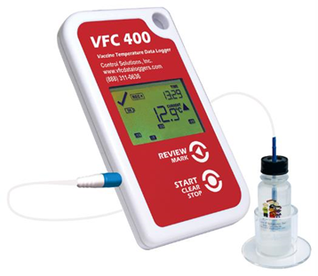
With a calibrated accuracy of ±0.6o F (0.3o C) over a measurement range of -40o F to 104o F (-40o C to 40o C), this DDL measures and stores up to 15,905 temperature readings from a remote temperature probe. A Wi-Fi cradle is an available option on this device for easier uploading of data. The display is designed to show “at a glance” if temperature violations have occurred during the current day and up to the previous 29 days. The display also shows the current temperature reading, the current time, recording status, and battery status. The alarm is triggered if temperature readings are outside pre-set alarm limits.

Features:
- NIST Traceable Certificate of Calibration compliant to ISO/IEC 17025:2005
- Audible and visual alarm for out-of-range temperatures
- Displays low-battery indicator, current temperature, minimum and maximum temperature, alarm, duration of alarm, time, recording, stopped, and summary of days collected
- User-programmable logging rate from every 30 seconds to hourly
- Wi-Fi cradle option available
- High-quality gold-plated remote sensor connector
- Includes software to download CSV files directly into NMSIIS without need for any further file manipulation
For more information, visit: http://www.vfcdataloggers.com

Some other Data Logger brands that generate files that are or can be modified to be compatible with direct temperature upload into NMSIIS are listed below. Please confirm and inquire about any additional costs with the manufacturer prior to purchase:
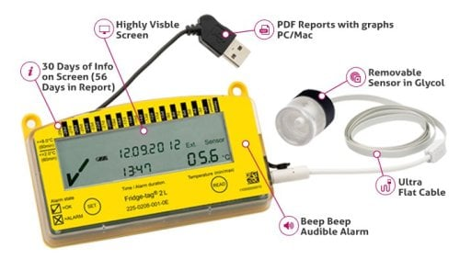
Berlinger Fridge-tag 2L
The Fridge-tag 2L is available in two configurations, one for use in a refrigerator and the other for a freezer. Fridge-tag 2L for Refrigerator with alarm settings at >8°C for 60 minutes and <2°C for 15 minutes. The alarms are configurable by the user. Fridge-tag 2L for the Freezer with an alarm set at >-15°C for 60 minutes. The alarm is set at the factory and locked. It cannot be changed by the user. The Fridge-Tag 2L comes with an external sensor in glycol bottle and an ISO 17025 certificate of calibration performed at a single temperature, which is 5°C for the refrigerator version and -20°C for the freezer version. The Fridge-tag 2L for the refrigerator with configurable alarms can be used as a backup device for use in either a refrigerator or freezer.

Features:
- No software = easy installation
- 3 Year ISO 17025 Calibration Certificate
- 62″ Sensor ULTRA Flat Cable Available
- +16,000 Recordings in Memory
- +/-0.5ºC Measuring Accuracy
- Large LCD Screen 1″ x 3.75″
For more information, visit: https://www.berlingerusa.com/fridgetag2l/

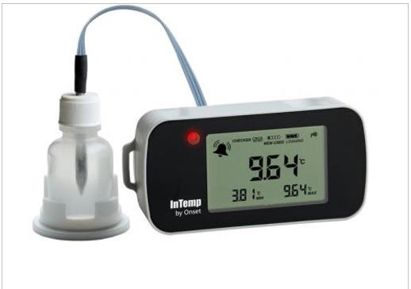
InTemp® VFC Bluetooth Low Energy Temperature (with Glycol) Data Logger (CX402- VFCxxx)

This DDL communicates wirelessly via Bluetooth Low Energy to mobile devices. Using the InTemp app, users can easily view data, check logger status, set alarms, and create and share secure PDF reports for streamlined reporting and regulatory compliance. All loggers feature a built-in LCD display to view current and daily minimum and maximum temperatures, advanced audible and visual alarm capabilities for notification of temperature excursions, an internal sensor for ambient temperature monitoring, and a 3-year NIST Certification of Calibration (probe only).

Features:
- Easy-to-read display with current and daily min/max temperatures
- Audible and visual alarms (remote alarms require the InTemp Gateway app)
- Bluetooth transmission of data and alarm states
- Logger setup and download of data in seconds – without a PC or cable
- ±1° F (0.5° C) accuracy for reliable temperature readings
- Battery-powered to guard against local power loss
- Several Glycol bottle sizes with probe and cable length options
- Includes 3-year ISO 17025 compliant calibration
For more information, visit: http://www.onsetcomp.com/intemp/

Fisherbrand Traceable Refrigerator/Freezer Alarm Thermometer
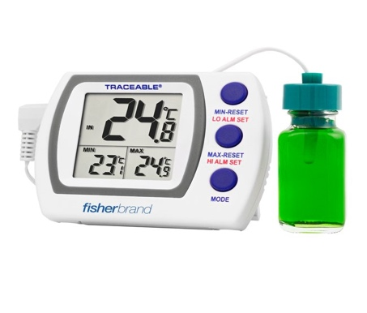
Provides accurate reading when freezer/refrigerator doors are open with temperature-buffered, sensor-sealed in bottled glycol solution. Fisher Scientific™ Traceable™ Refrigerator/Freezer Alarm Thermometer shows current, high and low temperatures and alerts user with visual and audible signals if temperature diverts from set points.

Features:
- Monitors temperature in freezers, refrigerators, incubators, water baths and heating blocks
- Triple display simultaneously shows current, high and low temperatures
- Alarm (Cat. No. 06-664-11 only) set in 1° increments alerts user with visual and audible signals if temperature goes outside setpoints
- 10 ft. long (3m) micro cable permits doors to close on it
- Dimensions: 4.25L × 2.75W × 0.75 in.H (11 × 7 × 2cm)
- Individually serial-numbered Traceable Certificate is provided from an ISO 17025 calibration laboratory accredited by A2LA™; indicates traceability to standards provided by NIST™.

For more information, visit: https://www.fishersci.com/us/en/browse/90198027/data-loggers

Additional DDL Options
Based on the above guidelines, the following is a brief list of equipment options that meet or exceed CDC requirements and/or recommendations. This list is by no means exhaustive and merely provides examples of continuous-monitoring DDLs to consider when purchasing. (See Contact Information, page 11, for more vendor options.) The output files from devices below may not meet the requirement for direct upload into NMSIIS. Please be sure to confirm compatibility with the manufacturers prior to decision-making.
Disclaimer: As a state-government entity, the NM VFC Program does not endorse any specific brand or product. The terms and conditions of a purchase are ultimately between a provider and its vendor.
SensoScientific VFC Digital Data Logger
For more information, visit: sensoscientific.com/vfc-data-loggers/
SensoScientific Wi-Fi VFC Digital Data Loggers are specifically designed to exceed CDC and VFC recommendations in every state. They can collect, store, and transmit data wirelessly via any Wi-Fi enabled network.

Features:
- Temperature range: -20°C to 150°C and accuracy of +/- 0.5°C
- Visual and audible alarm
- Immediate alert notifications via SMS, text, voice, cell phone, pager, fax, and email
- Automated min/max reporting
- True embedded Wi-Fi solution
- Easy-to-read display with current and daily min/max temperatures
- Detachable buffered probe
- 5- to 15-minute logging intervals
- Includes software to download CSV files directly into NMSIIS without need for any further manipulation
- Dual power – battery/AC power
- NIST Certified and A2LA Accredited Snap calibration

Excursion-TracTM Traceable® Refrigerator/Freezer Datalogger with one bottle (Manufacturer Item No. 6430)
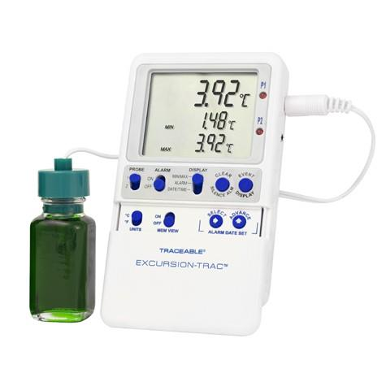
Features:
- Meets current CDC requirements for vaccine storage and
monitoring
- Temperature range of -58° to -158° F (-50° to -70°C)
- Hi/Lo alarms and Time/Date stamps
- Rolling memory structure, maintains most recent 525,600
temperature observations
- Smart-Alarm™ signals out-of-range conditions
- Status indicators: Low battery, memory full and active alarm state
- Allows recorded data (CSV file) to be transferred from DDL to PC or Mac using a USB flash drive (not included)
- Monitors readings overnight, on weekends, or for any time period with rolling data log
- Bottle probes sealed in a miniature bottle filled with nontoxic glycol
- Traceable® Certificate which assures accuracy from the manufacturer’s ISO/IEC 17025:2005 (1750.01) calibration laboratory accredited by A2LA
For more information, visit: http://www.traceable.com

Additional Equipment

The following lists additional equipment a provider may consider when assessing its vaccine storage needs. (See Contact Information, pages 7-8, for more vender options.)

Alarm Telephone Dialers
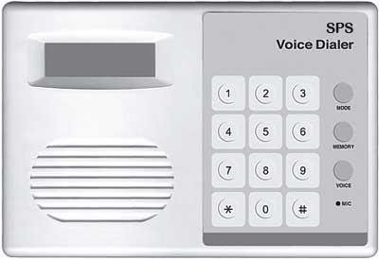
These devices, though a relatively old technology, may be useful to providers with limited internet connectivity or recurrent power outages. They are sold by several manufacturers in varied models, styles, and prices to choose from.

Alarm telephone dialers are designed to call pre-determined telephone numbers when temperatures go out of range and are a simple and reliable alarm option, provided the system is accurate.

Maintaining a temperature reading that mirrors a current calibrated continuous-monitoring DDL is imperative to the usefulness of a dialer.

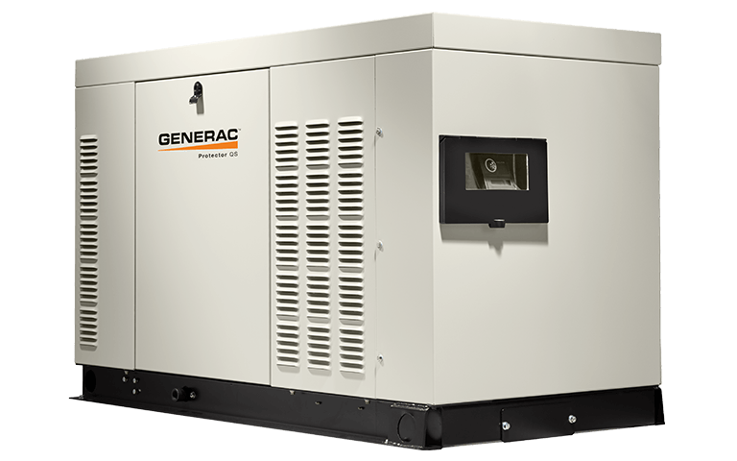
Emergency Power Generators
Disruption in the power supply is one of the most frequent causes of costly vaccine loss, since it does not take long for a refrigerator or freezer to warm up due to a power outage and thus compromise vaccine integrity. Healthcare providers (especially those in rural or coastal areas, or those storing large vaccine inventories) should seriously consider having an emergency power generator in place should an emergency occur. If a provider already has such a unit in place, it must make sure a vaccine refrigerator and freezer are connected to that power circuit.

According to the CDC, emergency power generators should be tested quarterly and receive maintenance at least annually (check manufacturer specifications for test procedures and maintenance schedules). In addition, sufficient fuel should be kept on hand to continuously run the generator for at least 72 hours.

Contact Information

New Providers: Interested in becoming a VFC Provider? Here is the link to the VFC New Provider Assessment https://www.surveymonkey.com/r/F95KMYQ

NM VFC Program For more information on VFC requirements or recommendations, please contact the NM VFC Program staff in your area: https://www.nmhealth.org/publication/view/general/1479/

NM VFC Program Provider Portal For new provider information, enrollment and re-enrollment forms, frequently asked questions, etc.: https://www.nmhealth.org/about/phd/idb/imp/vfc/provider/

NM VFC Program Patient Portal For patient information on receiving vaccines or getting shot records: https://www.nmhealth.org/about/phd/idb/imp/vfc/patient/

Calibration Listings of ILAC/MRA-accredited calibration laboratories may be obtained through the following participating organizations:
- AIHA National Accreditation Programs, LLC (AIHA-LAP, LLC): http://www.aihaaccreditedlabs.org
- American Association for Laboratory Accreditation (A2LA): http://www.a2la.org
- ANSI National Accreditation Board (ANAB): https://www.anab.ansi.org
- International Accreditation Service (IAS): http://www.iasonline.org
- National Voluntary Laboratory Accreditation Program (NVLAP): http://www.nist.gov/nvlap
- Perry Johnson Laboratory Accreditation, Inc. (PJLA): http://www.pjlabs.com

DDL Vendors Providers have many options when it comes to purchasing DDLs. The following list includes some examples of vendors and manufacturers:
- Control Solutions, Inc.: http://www.vfcdataloggers.com
- Berlinger: https://www.berlingerusa.com/
- Onset https://www.onsetcomp.com/intemp/
- Fisher https://www.fishersci.com/us/en/browse/90198027/data-loggers

- CAS DataLoggers: http://www.dataloggerinc.com
- DeltaTrak: http://www.deltatrak.com
- Dickson: http://www.dicksondata.com
- InTemp® by Onset: http://www.onsetcomp.com/intemp/
- Lascar: http://www.lascarelectronics.com
- LogTag Recorders Ltd.: http://www.logtagrecorders.com
- MicroDaq.com, Ltd.: http://www.microdaq.com
- Thermco Products: http://www.thermcoproducts.com
- ThermoWorks: http://www.thermoworks.com
- Traceable Products: http://www.traceable.com

Alarm Telephone Dialers Vendors Providers have many options when it comes to purchasing dialers. The following list includes some examples of vendors and manufacturers:
- Sensaphone: http://www.sensaphone.com
- Dickson: http://www.dicksondata.com
- United Security Products: http://www.unitedsecurity.com
- Security Product Solutions: http://www.securityproductsolutions.com

Emergency Power Generator Vendors There are many manufacturers and vendors selling generators. The following list includes some examples of vendors and manufacturers:
- Generac: http://www.generac.com
- Cummins: http://www.cummins.com/generators
- Kohler: http://www.kohlerpower.com/home/index.html
- Briggs & Stratton: http://www.briggsandstratton.com/na/en_us/products/generators.html

Endnotes

1 As defined by the CDC, an “appropriate entity” will issue a certificate of calibration containing at least one of the following five items about calibration testing: - Conforms to International Organization for Standardization (ISO) 17025 standards. - Was performed by an International Laboratory Accreditation Cooperation/Mutual Recognition Agreement (ILAC/MRA)-accredited laboratory. - Is traceable to the standards maintained by the National Institute of Standards and Technology (NIST). - Meets specifications and testing requirements for the American Society for Testing and Materials (ASTM) Standard E2877 tolerance Class (< 0.5° C) or better. - Includes reference to another acceptable accuracy validation method, such as comparison to other traceable reference standards or tests at thermometric fixed points.
2 Chojnacky, M.; Miller, W.; and Strouse, G. Data Logger Thermometers for Vaccine Temperature Monitoring, http://nvlpubs.nist.gov/nistpubs/ir/2012/NIST.IR.7899.pdf
3 Centers for Disease Control and Prevention. Vaccine Storage & Handling Toolkit: January 2019, http://www.cdc.gov/vaccines/hcp/admin/storage/toolkit/storage-handling-toolkit.pdf

